Dynamic Bioreactor for Use in Intervertebral Disc Mechanobiology

Amanda Beatty, Dean Stolworthy, Kiarah Chrisman, Anton Bowden
Brigham Young University

Background
Lower back pain is a growing problem in the world, with as much as 30% of the adult population suffering from chronic back pain [1,2]. As such, a lot of research is being conducted on spines to help prevent and reduce back pain [2,3]. Intervertebral discs are a common source of the pain from herniation and disc degeneration, and research is often conducted on intervertebral discs outside the body [3]. The disc cells immediately begin to die when removed from its native environment within the body, thereby limiting the amount of accurate research and therapy that can be conducted [4]. The goal of this project is to keep intervertebral discs alive outside the body for an extended period of time for use in medical research.

Methods
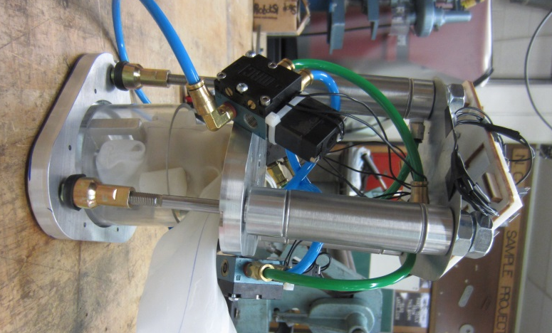
To keep the intervertebral discs alive, an alpaca functional spinal unit (FSU) will be placed inside a container with culture media that has all of the nutrients necessary for the cells to keep living, and antibacterial solution to reduce the incidence of contamination. Alpaca FSU’s are being used because of their similarity to the human spine [5]. The cells on the perimeter of the disc (annulus fibrosis) will be in contact with the culture media, but the inner cells (nucleus pulposus) will not have easy access to the nutrients in the media. To help with this issue two things will occur: 1) the vertebrae will be hollowed out to expose the cartilage endplate and simulate in-vivo conditions by allowing the nutrient-rich culture media to better diffuse through the endplate into the disc, and 2) the FSU will be dynamically loaded in flexion-extension (FE), lateral-bending (LB) and cyclic compression to facilitate the diffusion of nutrients into the nucleus pulposus. The dynamic loading will also assist in mixing up the media so there is an even distribution of nutrients, further extending the life of the disc. See Figure 1 for an image of the dynamic bioreactor setup.
Figure 1: Bioreactor with pneumatic cylinders powered by an Arduino.

Live/dead cell staining will be conducted to determine the percentage of the disc cells that are still alive at the end of the experiment. Two static tests will simultaneously be conducted and the cells will be compared to the disc in the dynamic test.

Results/Discussion
The expected outcome of this experiment is that the disc placed in the dynamic bioreactor will have a significantly higher percentage of living cells at the end of the cycle than the discs in the static tests. This will provide a method for medical professionals to keep intervertebral discs alive outside the body, and a way to conduct research on living intervertebral disc cells in an effort to reduce back pain.

References
[1] Moffat et al "The cost of back pain." Centre for Health Economics, York (1995).
[2] Manchikanti et al "Comprehensive review of epidemiology, scope, and impact of spinal pain." Pain Physician 12, no. 4 (2008): E35-70.
[3] Burke et al "Intervertebral discs which cause low back pain secrete high levels of proinflammatory mediators." Journal of Bone & Joint Surgery, British Volume 84, no. 2 (2002): 196-201.
[4] Buckwalter "Aging and degeneration of the human intervertebral disc." Spine 20, no. 11 (1995): 1307-1314.
[5] Stolworthy et al "Animal Model of Intervertebral Disc Regeneration: Camelids."Emerging Ideas in Biomedical Research (2012).

